Developing your understanding 16.8

1 Who was Confucius?

2 Discuss why people were attracted to his ideas.

3 What is the Lun Yu?

4 Where and with whom did Buddhism originate?

5 Explain how Buddhism reached China.

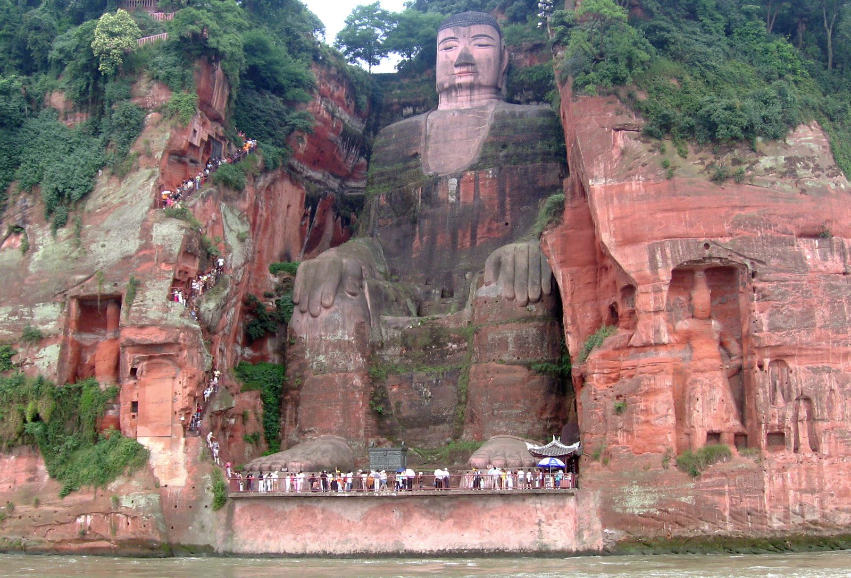
Source 16.16 Leshan Giant Buddha, in Sichuan province in south-western China,
is the largest Buddhist statue in the world and tookabout 90 years to build
(713–803 ce). It is 71 metres high and is carved out of the cliff face.

6 Consider what Source 16.16 suggests about the impact of Buddhism in China.

7 Design a poster to depict important aspects of one of these philosophies. The poster should be designed to be used as a teaching resource for display in a Years 7–8 classroom. Write a 250-word explanation of the connection between the aspects and how they are presented in the poster.

